Special Education Training Alliance (SETA)  (Western Suburbs State Special School)  RTO number: 41021  SETA operates as a central RTO across a number of Specials in Queensland and offers students the ability to complete Certificates within their individual school sites. Specific course availability depends on site staffing, facilities and the cohort of students in attendance. |  | 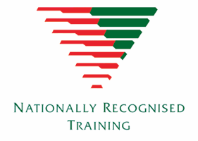

BSB10120 – Certificate I Workplace skills
Qualification description  This qualification focuses on the basic skill sets for students to needed to use a computer in workplace.  Refer to training.gov.au for specific information about the qualification.  Entry requirements  There are no entry requirements for this qualification.  Duration and location  This is a one or two-year course delivered in Years 10, 11 and 12 on your school site. | Delivery modes  A range of delivery modes will be used during the teaching and learning of this qualification. These include:  - face-to-face instruction  - guided learning.  Fees  Refer to individual site to ascertain if there are fees applicable for course.
Course units  To attain a BSB10120 Certificate I Workplace Skills, 6 units of competency must be achieved:  Unit code Title  BSBOPS101 Use Business Resources  BSBPEF101 Plan and prepare for work readiness  BSBDAT201 Collect and record data  BSBTEC101 Operate digital devices  BSBTEC203 Research using the internet  FSKDIG002 Use digital technology for routine and simple workplace task | Assessment  Assessment is competency based and completed in a simulated workplace environments.  Units of competency are clustered and assessed in this way to replicate what occurs in office/workplace environments as closely as possible.  Assessment techniques include:  - Observation  - Oral Response  - Product review  - Portfolio of evidence
RTO obligation  The RTO guarantees that the student will be provided with every opportunity to complete the qualification. We do not guarantee employment upon completion of this qualification.  Students who are deemed competent in all 6 units of competency will be awarded a Qualification and a record of results.  Students who achieve at least one unit of competency (but not the full qualification) will receive a Statement of Attainment. | Pathways  This qualification may articulate into:  - BSB20120 Certificate II in Workplace Skills  - work within business environment with support  See other BSB qualifications at training.gov.au.

